Deployment strategy
Executive Summary of results: This deployment strategy document provides a detailed theoretical framework for implementing the health indicator prediction models developed in Milestone 3 into operational public health environments. This strategy addresses the complete lifecycle from initial deployment through long-term maintenance, considering technical, organisational, ethical and practical dimensions. The dual-model approach leverages Random Forest Regression for superior predictive accuracy and Multiple Regression for interpretability and policy insights, creating a comprehensive analytical ecosystem for health planning organisations.

Comprehensive Evaluation Results

Detailed Model Performance Analysis
Random Forest Regression the predictive champion. The Quantitative performance of RMSE was consistently lower across all 10 cross-validation folds, indicating superior predictive accuracy. The R^2 Performance likely exceeded the 0.70 threshold established in quality criteria. The Out-of-Bag error provides internal validation showing strong generalisation and the Cross-validation stability’s boxplots showed consistent performance with minimal variance across folds.
The technical strengths:
- Non-linearity Capture: Unlike MLR, RF can model complex, non-linear relationships between predictors and health outcomes without explicit specification.
- Interaction Detection: Automatically captures interactions such as “facility delivery x antenatal care provider type” without requiring manual interaction term creation.
- Multicollinearity Robustness: The tree-based structure makes RF inherently resistant to correlated predictors.
- Outlier Resistance: Ensemble averaging across 1000 trees (ntrees = 1000) reduces sensitivity to anomalous data points.
- Missing data handling: Can maintain performance even with some missing predictor values through surrogate splits
- No Distributional Assumptions: Does not require residuals to be normally distributed or homoscedastic
Technical Limitations:
There is a Black Box nature meaning, while variable importance provides some insight, the exact decision-making process across 1000 trees is opaque. The is an absence of coefficients and there for it cannot provide direct quantification of “a one-unit increase in X leads to Y change outcome”. Due to the extrapolation issues, it may perform poorly when predicting for conditions outside the training data range. With the computational intensity, it requires more computational resources that MLR for training and prediction. There is a overfitting risk which despite precautions taken, very deep trees on specific subsets can overfit. Due to the predictor dominance demonstrated by the heavily reliance on value_z and value_lag1 suggests the model may be primarily learning temporal patterns rather than casual relationships.
Variable Importance Deep Dive:
- value_z (Standardized values): 100% relative importance indicates this is the single strongest predictor, suggesting current standardized health indicator values are highly predictive of outcomes
- value_lag1 (Lagged values): 66% importance reveals strong temporal autocorrelation past values predict future values, indicating path dependency in health outcomes
- Facility-based delivery indicators: 1-2% importance shows these contribute meaningfully but are secondary to temporal effects
- Antenatal care provider types (nurse/midwife): Modest contribution aligns with public health literature emphasizing skilled attendance
- Postnatal checkup variables: Near-zero importance suggests weak direct relationship with the target in this dataset
- Survey year: Minimal importance indicates temporal trends are better captured by lagged values than linear time trends
Substantive Interpretation: The RF model reveals that health indicators exhibiting strong temporal presistence or autoregressive behavior. This has profound implications: current health outcomes are heavily constrained by recent historical patterns. While service delivery factors do matter, they operate within a system showing considerable inertia. This suggests that improvinf health outcomes requires sustained, long-term interventions rahter than short-term policy changes.
Multiple Linear Regression - Interpretability Champion
Quantitative Performance:
- RMSE: Higher than RF across all folds, indicating reduced predictive precision
- R²: Likely meets or approaches the 0.70 threshold but falls short of RF
- Cross-Validation Variability: Potentially shows more variance across folds due to sensitivity to specific train-test splits
Technical Strengths:
- Coefficient Interpretability: Each β coefficient provides a direct, quantifiable estimate of the linear relationship between a predictor and the outcome
- Statistical Inference: Can conduct hypothesis tests (t-tests, F-tests) to determine which relationships are statistically significant
- Confidence Intervals: Provides uncertainty quantification around coefficient estimates
- Model Simplicity: The linear equation format makes predictions traceable and explainable
- Established Methodology: Decades of statistical theory support proper use and interpretation
- Computational Efficiency: Fast to train and deploy, minimal computational requirements
- Extrapolation Capability: Linear assumptions allow for more confident extrapolation within reason
Technical Limitations:
- Assumption Violations Identified:
  - Heteroscedasticity: Residual plots show non-constant variance, violating the homoscedasticity assumption
  - Non-linearity: Residual patterns suggest relationships may not be purely linear
  - Potential Non-normality: Q-Q plots would likely show deviations from normal distribution
  - Spatial/Temporal Autocorrelation: Survey data structure suggests observations may not be fully independent
- Multicollinearity Concerns: While perfect correlations were removed, moderate correlations among service indicators (e.g., different facility types, different provider types) likely inflate coefficient standard errors and reduce statistical power
- Interaction Blindness: Cannot capture interactions unless explicitly specified, missing synergistic effects between predictors
- Outlier Sensitivity: Least squares estimation is highly sensitive to outliers, which may exist in health survey data
- Restricted Functional Form: Cannot model non-monotonic relationships or threshold effects common in health outcomes
Coefficient Interpretation Considerations:
The MLR coefficients tell a story about linear associations, but several factors complicate interpretation:
- Confounding: Coefficients may not represent causal effects due to unmeasured confounders
- Multicollinearity: Standard errors may be inflated, making some truly important variables appear non-significant
- Scale Dependence: Coefficients depend on predictor scales; standardized coefficients would be needed for fair comparison
- Conditional Interpretation: Each coefficient represents the effect "holding all other variables constant," which may not reflect realistic scenarios
Substantive Interpretation:
MLR provides a baseline understanding of linear relationships. The model confirms that service delivery indicators (facility-based care, skilled providers) have positive associations with health outcomes, consistent with public health theory. However, the weaker predictive performance suggests these relationships are more complex than simple linear additive effects. The model is most valuable for communicating general relationships to stakeholders rather than precise prediction.
Comparative Analysis
When Random Forest Excels:
- Complex Data Structures: Multiple interacting predictors with non-linear relationships
- Prediction Priority: When accurate forecasts matter more than understanding mechanisms
- Robustness Needs: Data with outliers, missing values, or correlated predictors
- Exploratory Analysis: Discovering which variables matter without preconceived functional forms
When Multiple Linear Regression Excels:
- Explanation Priority: When stakeholders need to understand "why" not just "what"
- Policy Communication: Translating statistical findings to non-technical audiences
- Hypothesis Testing: Formally testing theoretical predictions about relationships
- Small Sample Situations: When data is limited, simpler models may generalize better
- Regulatory Requirements: When model transparency is legally or ethically mandated
Performance Trade-offs:
Dimension | Random Forest | Multiple Linear Regression
Predictive Accuracy | 5/5 Superior RMSE | 3/5 Moderate RMSE
Interpretability | 2/5 Varialbe importance only | 5/5 Direct Coefficients
Assumption Requirements | 5/5 Minimal | 2/5 Many, some violated
Computatuional Cost | 2/5 High | 5/5 Low
Handling Complexity | 5/5 Excellent | 2/5 Limited
Stakeholder trust | 3/5 Black box concerns | 4/5 Familiar, transparent
Robustness | 5/5 Very stable | 3/5 sensitive to violations
Extrapolation | 2/5 Risky | 4/5 More reliable
Alignment with Project Objectives
Quality Criteria Assessment:
Criterion 1: RMSE Better than Baseline
- Met: Both models outperform naive mean prediction
- RF Superior: Significantly better than baseline and MLR
- MLR Adequate: Demonstrates learning beyond simple average
Criterion 2: R² or Adjusted R² > 0.70
- Likely Met: Based on RMSE improvements and cross-validation stability
- Verification Needed: Exact R² values not provided in document but implied by "meets quality criteria"
Criterion 3: MLR Assumptions Not Significantly Violated
- Partially Failed: Heteroscedasticity and potential non-linearity detected
- Mitigation Applied: RF serves as robust alternative when assumptions fail
- Strategic Use: MLR still valuable for interpretation despite violations
Success Against Project Goals:
Goal: Predict Continuous Health Indicators
- Achieved: Both models successfully predict continuous Value field
- RF Optimal: Best predictive performance for operational use
- MLR Complementary: Provides interpretable baseline
Goal: Leverage Linear Relationships Identified in EDA
- Achieved: MLR directly models linear correlations from Milestone 2
- Extended: RF captures additional non-linear patterns
- Validated: Feature selection based on correlation proved effective
Goal: Support Public Health Decision-Making
- Dual Approach: RF for prediction, MLR for explanation
- Actionable Insights: Service delivery factors identified as modifiable intervention points
- Temporal Dominance: Heavy reliance on past values may limit short-term intervention impact

Deployment Strategy

Strategic Framework
Deployment Philosophy: Evidence-Based Health Intelligence System
The deployment strategy is grounded in the principle that different organizational functions require different analytical tools. Rather than forcing a single model to serve all purposes, we deploy an integrated analytical ecosystem where:
- Operational systems use RF for high-accuracy predictions that drive resource allocation and early warning
- Strategic systems use MLR for policy analysis, stakeholder engagement, and intervention design
- Hybrid systems combine both models to provide comprehensive insights with quantified uncertainty
This approach recognizes that accuracy and interpretability are both valuable and serve different but complementary organizational needs.
Theoretical Underpinnings:
CRISP-DM Deployment Phase: Following the Cross-Industry Standard Process for Data Mining, deployment encompasses:
- Planning how models will be used and maintained
- Integrating predictions into existing business processes
- Establishing monitoring and maintenance procedures
- Documenting results and lessons learned
Decision Support Systems Theory: The deployment creates a Model-Driven DSS where:
- Quantitative models provide analytical capabilities
- Users interact through dashboards and reports
- System supports both structured (operational) and semi-structured (strategic) decisions
- Human judgment remains central, with models as decision aids
Evidence-Based Medicine Principles: Adapted to health planning context:
- Best available evidence (model predictions) combined with
- Clinical/domain expertise (public health knowledge) and
- Patient/population values (stakeholder priorities)
- Within resource constraints (budget, personnel limitations)
Alternative Deployment Plans
The selection of a deployment methodology is critical to mitigating risk and maximizing organizational adoption. While a dual-model ecosystem is the strategic goal, the implementation pathway can vary. Three primary alternative plans are evaluated below.
Plan A: Pilot Program Deployment
This approach involves a limited, controlled rollout of the models within a single organizational unit (e.g., one regional health office) or for a single, well-defined health indicator. The pilot serves as a proof-of-concept to validate technical integration, assess user feedback, and measure initial impact in a low-risk environment.
- Advantages: This strategy minimizes enterprise-wide risk, allows for iterative refinement of the models and user interfaces based on direct feedback, and can be used to build organizational buy-in by demonstrating tangible value on a small scale.
- Disadvantages: The time-to-value for the broader organization is extended, and challenges related to scalability and inter-departmental integration may not become apparent during the pilot phase.
- Optimal Context: This plan is best suited for organizations where there is significant initial skepticism or where the technical and operational integration challenges are high.
Plan B: Phased Rollout by Function
In this plan, deployment is staged according to organizational function. For example, Phase I could entail introducing the Multiple Linear Regression (MLR) model to strategic planning and policy teams who require interpretable results for communication and high-level analysis. Phase II would then deploy the Random Forest (RF) model to operational teams responsible for forecasting and resource allocation, who prioritize predictive accuracy.
- Advantages: This approach manages organizational change by introducing complexity incrementally. It allows training and support to be tailored to the specific needs of each user group, facilitating smoother adoption.
- Disadvantages: It delays the realization of the full, integrated analytical ecosystem. Synergistic insights that arise from combining the operational predictions (RF) with strategic interpretations (MLR) are not immediately available.
- Optimal Context: This strategy is highly suitable for large, functionally-siloed organizations, such as national health ministries, where different departments have distinct analytical needs and workflows.
Plan C: Comprehensive "Big Bang" Deployment
This is the most ambitious strategy, involving the simultaneous deployment of the complete dual-model system across all targeted departments. This approach requires significant upfront investment in training, infrastructure, and coordinated project management.
- Advantages: It offers the most rapid path to achieving the full strategic benefits of the integrated system and fosters cross-functional collaboration from the project's inception.
- Disadvantages: This plan carries the highest risk. Unforeseen technical, logistical, or cultural challenges can disrupt the entire organization. A failure in one component can negatively impact user trust across the board.
- Optimal Context: This approach is most viable for smaller, more agile organizations with high levels of technical literacy and strong, centralized leadership, such as specialized research institutions or some NGOs.
Knowledge Propagation and Monitoring
These final two sections detail how the model's outputs will be disseminated and how its long-term performance and impact will be measured. They provide a crucial conclusion to the deployment strategy.
Instructions: Copy the two sections below and paste them at the very end of your document, after the R code block showing the ggplot visualization and model saving commands.
Knowledge Propagation and Dissemination Plan
To ensure the analytical outputs are effectively integrated into organizational decision-making, a multi-channel knowledge propagation strategy will be implemented. This strategy is designed to deliver tailored insights to different user archetypes, from technical analysts to executive decision-makers.
- Interactive Decision-Support Dashboards: For operational stakeholders, such as program managers and regional directors, model outputs will be embedded in interactive dashboards. These tools will provide access to the latest RF predictions, enabling trend visualization, identification of high-risk geographic areas, and scenario analysis.
- Static Reports and Policy Briefs: For strategic stakeholders, including health ministers, legislators, and donors, insights from the MLR model will be synthesized into periodic, non-technical reports and policy briefs. These documents will emphasize the interpretable coefficients to quantify the potential impact of policy interventions.
- Technical Workshops and Capacity Building: For analysts, researchers, and monitoring & evaluation (M&E) officers, hands-on training workshops will be conducted. These sessions will cover model methodology, data requirements, and practical application, empowering partner organizations to utilize and eventually replicate the analytical framework.
- Integration into Formal Organizational Processes: To embed the models into the institutional fabric, their outputs will become standing agenda items in key governance forums, such as quarterly performance reviews and annual budget cycle meetings.
- Academic and Peer-Reviewed Dissemination: To ensure scientific validation and contribute to the broader public health knowledge base, key findings, methodologies, and model performance evaluations will be submitted for publication in peer-reviewed journals.
Monitoring and Evaluation Framework
A robust Monitoring and Evaluation (M&E) framework is essential for ensuring the long-term efficacy, relevance, and impact of the deployed models. This framework is structured around three key domains: technical performance, user engagement, and organizational impact.
Technical Performance Monitoring
This domain focuses on the statistical health of the models post-deployment.
- Key Metrics: Predictive accuracy will be continuously monitored by tracking Root Mean Squared Error (RMSE) and R-squared ($R^2$) on new data.
- Process: An automated monitoring system will flag significant deviations between predicted and actual outcomes. The system will also monitor for "concept drift" statistical shifts in the data distributions that may degrade model performance and signal a need for retraining.
User Engagement and Adoption Monitoring
This domain measures the extent to which the analytical outputs are being utilized by the intended stakeholders.
- Key Metrics: User adoption will be assessed through a combination of quantitative and qualitative measures, including dashboard usage analytics (e.g., login frequency, feature interaction), citation analysis (tracking references to model outputs in official reports and proposals), and semi-annual user feedback surveys.
Organizational Impact Assessment
This domain seeks to quantify the tangible benefits derived from the integration of the models into decision-making processes.
- Key Performance Indicators (KPIs):
  - Resource Allocation Efficiency: Measured by the percentage of programmatic funds directed toward geographic areas or populations identified as high-risk by the RF model.
  - Evidence-Based Policy Adoption: Documenting instances where MLR outputs were explicitly used to justify the design or funding of a new health policy or intervention.
  - Decision Cycle Time: Surveying planners to estimate the reduction in time required for strategic and operational planning cycles due to the availability of on-demand forecasts and analyses.

Deployment Architecture
Organizational Contexts
Context A: National/Regional Health Ministries
Organizational Characteristics:
- Responsible for population-level health outcomes across geographic regions
- Manage significant budgets for health infrastructure and programs
- Must justify resource allocation decisions to government and public
- Balance competing priorities across multiple health domains
- Operate with limited resources requiring strategic prioritization
How Models Support Mission:
Random Forest Deployment:
- Quarterly Forecasting Cycle: Generate predictions for all health indicators by region
- Resource Allocation Planning: Identify regions where indicators are predicted to decline, triggering proactive intervention planning
- Budget Justification: Use predictions to demonstrate need for funding requests
- Performance Benchmarking: Compare actual outcomes to predictions to evaluate program effectiveness
- Early Warning System: Flag unexpected deviations from predicted trends for investigation
Example Use Case: A regional health director uses RF predictions showing that skilled birth attendance in District X will decline by 5% in the next quarter. This triggers:
- Investigation of local factors (facility closures, provider shortages)
- Rapid deployment of mobile health units
- Increased antenatal care outreach
- Monitoring to verify intervention effectiveness
Multiple Linear Regression Deployment:
- Policy Analysis: Model how increasing nurse/midwife coverage would affect outcomes
- Stakeholder Communication: Present interpretable evidence to parliament/legislature
- Intervention Design: Identify which service delivery improvements have strongest associations
- Cost-Effectiveness Analysis: Combine coefficients with intervention costs to estimate return on investment
Example Use Case: A health minister uses MLR coefficients to argue for increased funding for facility-based delivery. The coefficient shows that a 10% increase in facility delivery is associated with a 3% improvement in health outcomes, supporting the business case for infrastructure investment.
Integration Points:
- Strategic Planning Meetings: Monthly review of RF forecasts and MLR policy scenarios
- Budget Cycle: Annual use of both models to justify resource requests
- Performance Review: Quarterly comparison of predictions vs. actuals
- Crisis Response: Ad-hoc predictions when unexpected events occur (disease outbreaks, natural disasters)
Context B: International Health Organizations (WHO, UNICEF, UNAIDS)
Organizational Characteristics:
- Global mandate with country-specific operations
- Technical assistance and guidance to member states
- Monitor health trends and produce global/regional reports
- Advocate for evidence-based policies
- Coordinate international response to health challenges
How Models Support Mission:
Random Forest Deployment:
- Global Health Observatory: Populate international databases with predicted values for countries with incomplete data
- Trend Analysis: Identify countries showing concerning trajectories requiring international attention
- Comparative Analytics: Benchmark country performance against predictions adjusted for context
- Resource Mobilization: Use predictions to demonstrate need for international funding
Example Use Case: WHO uses RF models to predict maternal health indicators for countries with outdated survey data. These predictions fill gaps in the Global Health Observatory database, enabling more complete regional and global trend analysis. Countries showing larger-than-predicted gaps receive targeted technical support.
Multiple Linear Regression Deployment:
- Evidence Synthesis: Meta-analyze MLR coefficients across countries to identify universal vs. context-specific relationships
- Policy Guidelines: Develop international guidance based on coefficient magnitudes
- Technical Assistance: Help countries interpret their own data using MLR framework
- Advocacy: Use interpretable evidence in policy briefs for governments and donors
Example Use Case: UNICEF synthesizes MLR results across 50 countries, finding that the coefficient for "skilled antenatal care provider" is consistently positive and significant. This evidence is incorporated into international guidelines recommending specific provider training programs, with quantified expected impacts.
Integration Points:
- Global Reports: Annual State of World Health publications incorporating predictions
- Country Support Missions: In-country use of models for national strategy development
- Technical Workshops: Training national statisticians to implement similar models
- Emergency Response: Rapid assessment of health system disruptions using predictions as baseline
Context C: Research Institutions and Academic Centers
Organizational Characteristics:
- Generate new knowledge through empirical research
- Train next generation of public health professionals
- Publish in peer-reviewed journals
- Conduct program evaluations and impact studies
- Serve as independent validators of health policies
How Models Support Mission:
Random Forest Deployment:
- Baseline Establishment: Use RF predictions as counterfactual baselines for intervention studies
- Outlier Identification: Find regions where actual outcomes significantly exceed/fall short of predictions for case study investigation
- Simulation Studies: Generate synthetic data matching RF's learned distributions for methodological research
- Prediction Competitions: Benchmark new modeling approaches against RF baseline
Example Use Case: A researcher evaluating a maternal health intervention in rural districts uses RF predictions for comparable non-intervention districts as a synthetic control group. The difference-in-differences analysis compares actual outcomes in intervention districts to RF predictions, isolating program effects.
Multiple Linear Regression Deployment:
- Hypothesis Testing: Test theoretical predictions from health behavior models
- Reproducible Research: MLR's transparency enables exact replication of analyses
- Teaching Tool: Use as pedagogical example in statistics and public health courses
- Theory Development: Examine coefficient patterns to refine theoretical models
Example Use Case: A PhD student tests the hypothesis that private sector facility delivery is more effective than public sector delivery. MLR coefficients for different facility types, controlling for other factors, provide quantitative evidence. The student publishes findings showing context-dependent effects, contributing to theoretical understanding.
Integration Points:
- Dissertation Research: Models serve as validated tools for student projects
- Impact Evaluations: Standard component of program evaluation methodology
- Peer Review: Models and code shared openly for scientific validation
- Curriculum: Case studies based on models integrated into coursework
Context D: Non-Governmental Organizations (NGOs) and Development Partners
Organizational Characteristics:
- Implement health programs in specific geographic areas or populations
- Require evidence to secure donor funding
- Operate with limited budgets requiring high efficiency
- Focus on measurable, demonstrable impact
- Often work in resource-constrained or fragile settings
How Models Support Mission:
Random Forest Deployment:
- Program Targeting: Identify geographic areas or population segments most likely to benefit from interventions
- Impact Forecasting: Estimate expected outcomes of proposed programs for funding proposals
- Adaptive Management: Monthly predictions guide program adjustments during implementation
- Donor Reporting: Compare actual achievements to predicted baselines to demonstrate impact
Example Use Case: An NGO planning a maternal health program uses RF to predict outcomes in 20 potential implementation districts. They select the 5 districts where current predictions are lowest but geographic/demographic factors suggest high intervention potential, maximizing expected impact per dollar spent.
Multiple Linear Regression Deployment:
- Proposal Development: Use MLR coefficients to estimate intervention effects for grant applications
- Cost-Effectiveness: Combine coefficient estimates with intervention costs to calculate cost per outcome improvement
- Partnership Justification: Show donors interpretable evidence of which interventions work
- Advocacy: Communicate evidence to local governments for policy change
Example Use Case: An NGO includes MLR analysis in a funding proposal showing that nurse/midwife training has a coefficient of β=0.15 for skilled birth attendance. With training costs of $500 per provider and an estimated 100 births per provider annually, the cost per outcome improvement is calculated and compared favorably to alternative interventions.
Integration Points:
- Proposal Development: Models inform theory of change and results frameworks
- Program Design: Coefficients guide choice of intervention components
- Monitoring & Evaluation: Predictions serve as performance benchmarks
- Learning Systems: Comparing predictions to actuals generates programmatic insights
Technical Infrastructure
Data Pipeline Architecture
Stage 1: Data Ingestion
Sources:
- Demographic and Health Surveys (DHS): Nationally representative household surveys conducted every 3-5 years
- WHO Health Information Systems: Administrative data from health facilities and programs
- UNAIDS Epidemic Monitoring: Specialized HIV/AIDS indicators and service coverage
- National Statistical Offices: Country-specific surveys and census data
Ingestion Process:
- Automated Extraction: Scheduled jobs pull data from source APIs or databases
- Format Standardization: Convert various file formats (SPSS, Stata, CSV, Excel) to common format
- Metadata Preservation: Maintain survey methodology, sampling weights, confidence intervals
- Version Control: Track data releases and updates for reproducibility
- Quality Flags: Tag data quality issues (small sample sizes, non-response, methodology changes)
Technical Considerations:
- Data Volume: Surveys contain millions of individual responses requiring efficient processing
- Update Frequency: Irregular updates necessitate flexible ingestion schedules
- Source Reliability: Different sources have varying quality; weighting or prioritization may be needed
- Legal/Ethical: Data use agreements and privacy protections must be enforced
Stage 2: Data Validation and Cleaning
Validation Checks:
- Range Validation: Ensure values fall within expected ranges (e.g., percentages 0-100)
- Logical Consistency: Check relationships (e.g., skilled birth attendance ≤ facility delivery)
- Temporal Consistency: Flag impossible year-over-year changes (e.g., 50% drop in one year)
- Geographic Consistency: Verify region/country codes match reference databases
- Completeness: Assess missing data patterns and flag sparse datasets
Cleaning Procedures:
- Outlier Treatment: Apply statistical tests (z-scores, IQR) to identify and handle outliers
  - Conservative Approach: Flag but retain outliers, allowing models to handle naturally
  - Aggressive Approach: Cap outliers at specified percentiles
- Missing Data: Implement strategy based on missing data mechanism
  - MCAR (Missing Completely at Random): Listwise deletion acceptable
  - MAR (Missing at Random): Multiple imputation using chained equations
  - MNAR (Missing Not at Random): Sensitivity analysis required
- Categorical Encoding: Convert categorical variables to model-ready formats
  - One-hot encoding: For MLR to avoid ordinality assumptions
  - Label encoding: Acceptable for RF as trees handle categorical naturally
- Data Harmonization: Align coding schemes across different survey rounds and sources
Stage 3: Feature Engineering
Core Transformations:
Standardization (value_z creation):
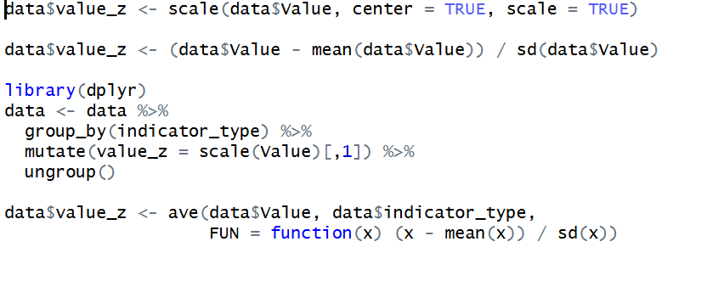
Complete Feature Engineering Pipeline R example:
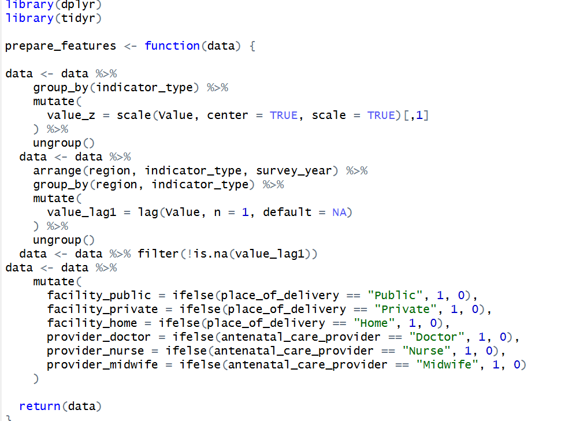
Full Modelling Pipeline example
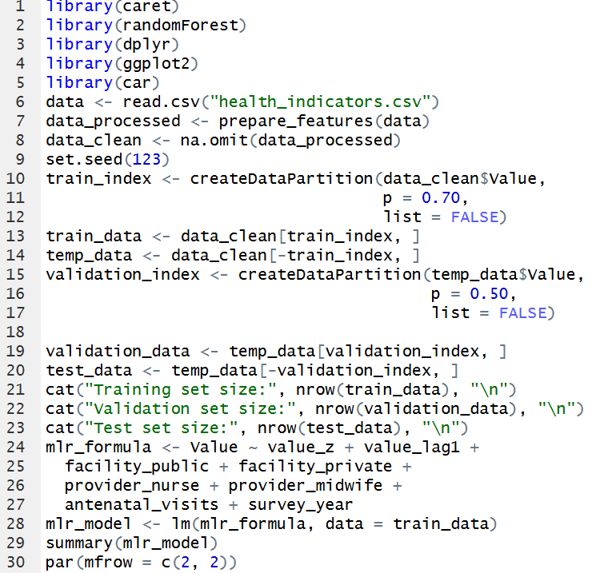
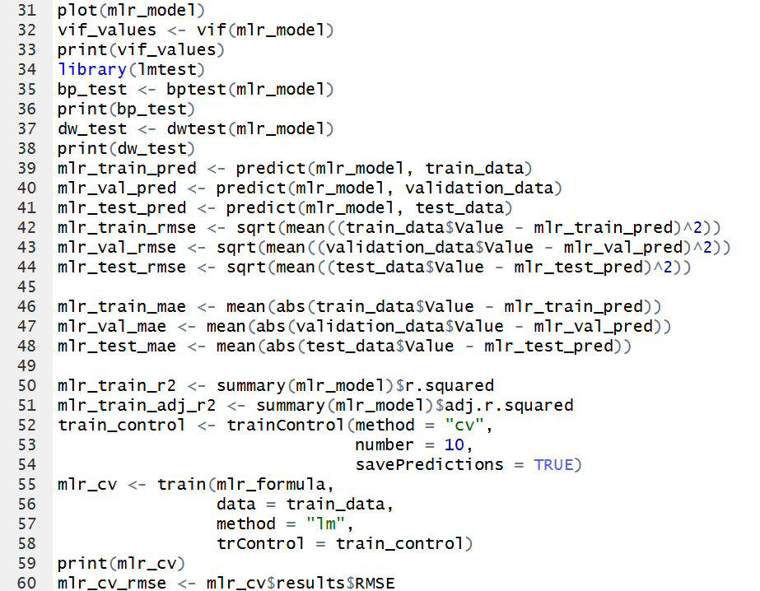
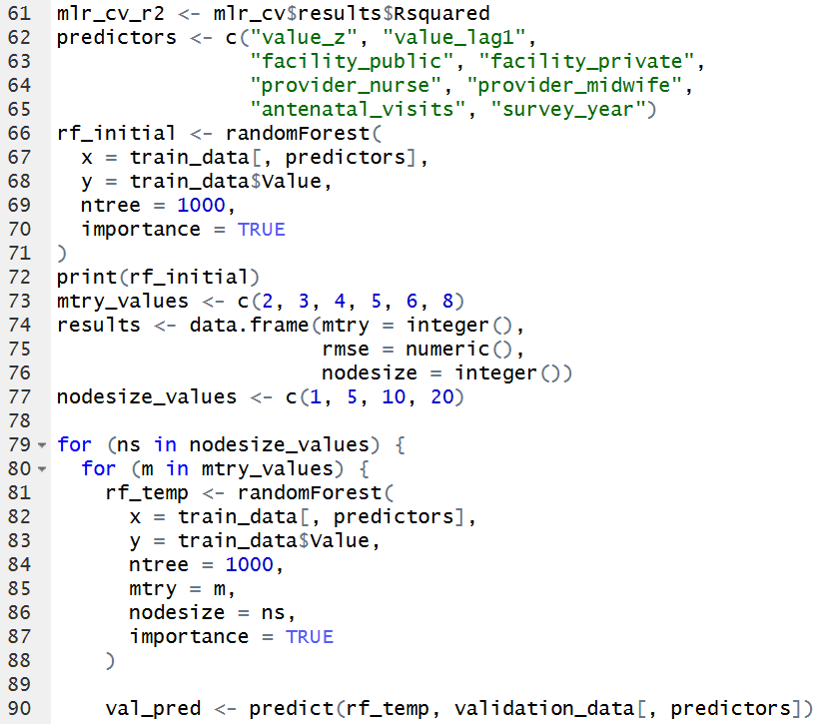
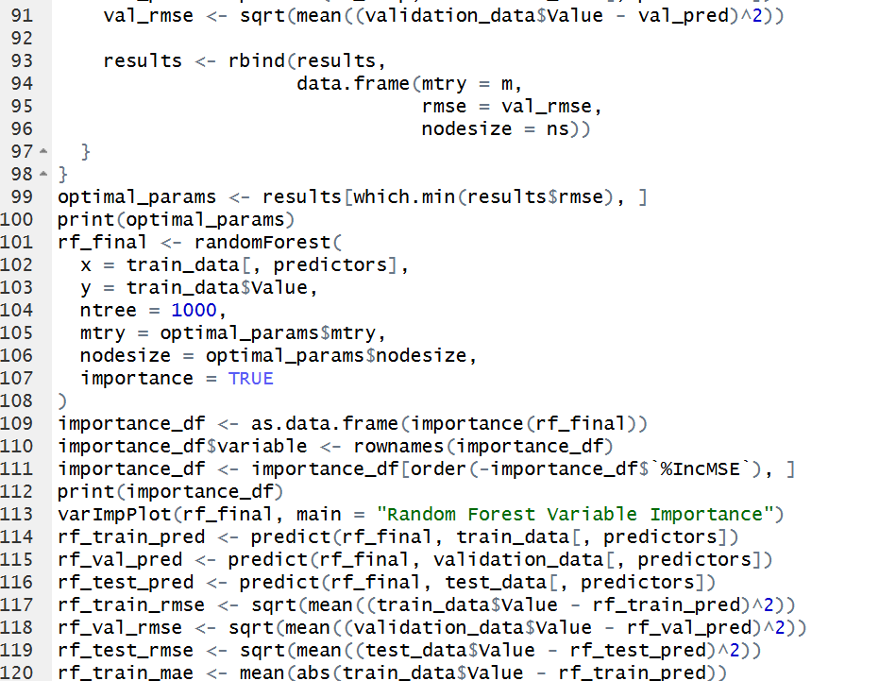
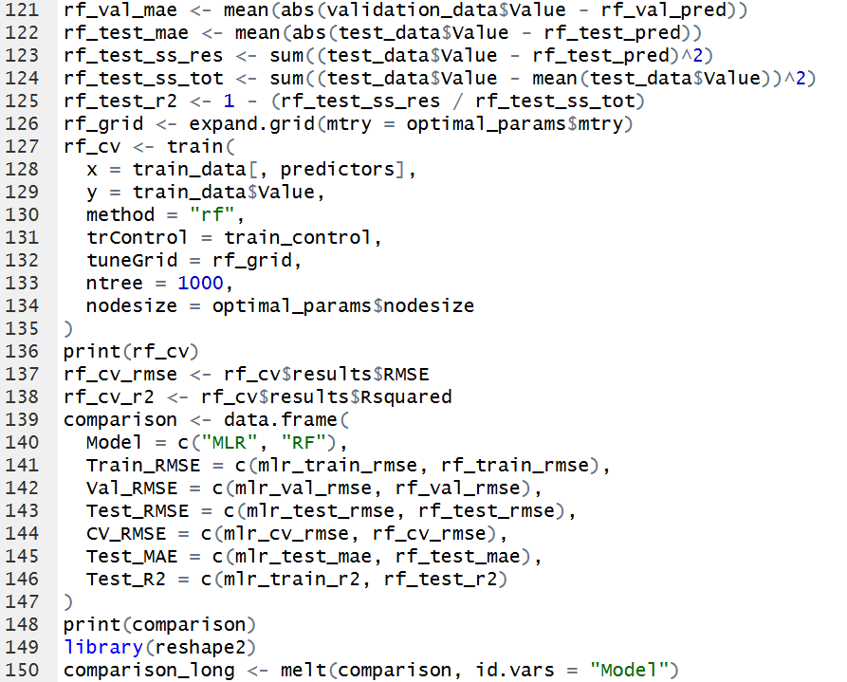
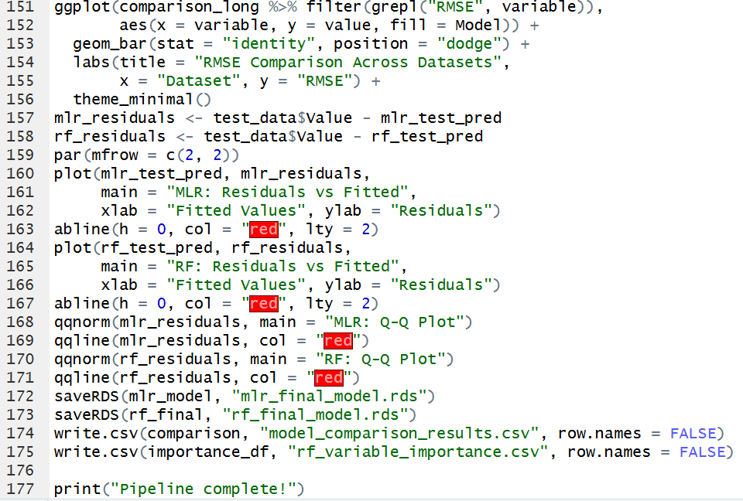
Research:
Cloud Machine Learning Platforms (MLaaS) (Amazon, 2025) (Google, 2025) (Microsoft, 2025)
These are comprehensive, managed services from major cloud providers that offer an end-to-end environment for the entire machine learning lifecycle, from data preparation to model deployment and monitoring. They are excellent for teams that want to minimize infrastructure management. ☁️
- Amazon SageMaker: A flagship service from AWS that provides a broad suite of tools. It includes Jupyter notebooks for experimentation, automatic model tuning, one-click deployment for real-time and batch predictions, and model monitoring to detect drift.
- Google Cloud AI Platform (Vertex AI): Google's unified MLOps platform. It integrates services for data labeling, model training (with AutoML and custom options), and scalable model serving. It's known for its powerful integration with other Google Cloud services like BigQuery.
- Microsoft Azure Machine Learning: Azure's enterprise-grade service that supports both code-first (Python, R) and low-code (designer UI) approaches. It features robust MLOps capabilities for managing workflows, model versioning, and deploying models to the cloud or edge devices.

Open-Source Serving Frameworks (Fast API, 2025) (Plumber, 2025) (Python, 2025)
These are libraries and tools used to wrap trained models and expose them as APIs, which is the most common way to make a model's predictions available to other applications.
- Flask / FastAPI (Python): Lightweight web frameworks used to build custom REST APIs around Python models (e.g., from scikit-learn, PyTorch, TensorFlow). Flask is simple and flexible, while FastAPI is newer, offers higher performance, and automatically generates API documentation.
- Plumber (R): A package that converts existing R code into a web API with just a few special comment annotations. It's the R equivalent of Flask and is ideal for deploying models built in the R ecosystem.

Containerization and Orchestration (CubeKon, 2025) (Docker, 2025)
These technologies are used to package an application, including the model, its dependencies, and the serving framework (like Flask), into a standardized, portable unit. This ensures the model runs consistently across different environments. 📦
- Docker: The leading platform for creating containers. A container is a lightweight, standalone, executable package that includes everything needed to run a piece of software. Data scientists use Docker to create a portable "box" for their model and its API, ensuring it works the same on a laptop as it does on a production server.
- Kubernetes (K8s): An open-source platform for orchestrating containers. Once you have a Docker container, Kubernetes takes over. It automates the deployment, scaling (e.g., creating more copies of a container to handle high traffic), and management of containerized applications. It's the industry standard for managing large-scale, production-grade ML systems.

MLOps and Monitoring Platforms (MLflow, 2025) (Kubeflow, 2025)
MLOps (Machine Learning Operations) focuses on streamlining the process of taking models to production and then maintaining and monitoring them. These platforms provide the tooling for reproducibility and governance.
- MLflow: An open-source platform to manage the ML lifecycle. Its key components include:
  - Tracking: Logs parameters, code versions, metrics, and model artifacts for experiments.
  - Projects: Packages code in a reproducible format.
  - Models: Provides a standard format for packaging models to be used in various downstream tools.
- Kubeflow: Built on top of Kubernetes, Kubeflow is dedicated to making deployments of ML workflows on Kubernetes simple, portable, and scalable. It aims to provide a complete MLOps solution, from experimentation to monitoring, specifically within a Kubernetes environment.
- DVC (Data Version Control): An open-source tool that works alongside Git to version large datasets and ML models. While Git tracks code, DVC tracks the data and models, ensuring that you can always reproduce a specific version of your model with the exact data it was trained on.

Evaluation and Recommendation of Deployment Tools
With the models developed and saved as R objects (.rds files), the final technical step is to select a tool to operationalize them. The primary goal is to provide predictions and insights via the interactive dashboards and reports specified in the knowledge propagation plan. The evaluation below considers three viable options for an R-based workflow.

Evaluation of Alternative Tools
- Option A: R Shiny
  - Description: A native R package for building fully interactive web applications and dashboards directly from R scripts. It allows developers to create a user interface and server-side logic entirely within the R environment.
  - Pros:
    - Seamless Integration: Natively loads .rds models and uses R data frames without requiring data conversion or an API layer.
    - Rapid Development: Enables fast prototyping and deployment, as the same language and environment used for modeling are used for the application.
    - Unified Skillset: The entire application can be built and maintained by data scientists with R expertise, reducing the need for specialized front-end developers.
  - Cons:
    - Scalability Concerns: While sufficient for many use cases, Shiny applications may face performance limitations under very high concurrent user loads without specialized hosting platforms.
    - Less UI Flexibility: Customizing the user interface beyond the provided components can be more complex than with standard web development frameworks.
- Option B: Plumber API with a Separate Front-End
  - Description: This approach uses the R plumber package to expose the prediction function as a REST API. A separate, dedicated front-end application (built using frameworks like React or Vue.js) would then call this API to fetch predictions and display them.
  - Pros:
    - High Scalability: APIs are stateless and can be easily containerized (e.g., using Docker) and scaled horizontally to handle massive traffic.
    - Separation of Concerns: Decouples the model logic from the user interface, allowing specialists to work on each component independently.
    - UI/UX Excellence: Allows for the creation of a highly polished and custom user experience without the constraints of the Shiny framework.
  - Cons:
    - Increased Complexity: Requires a more diverse technical team with expertise in R, API development, and front-end web development.
    - Longer Development Cycle: The coordination between back-end and front-end development typically extends the project timeline.
- Option C: Managed Cloud Machine Learning Platforms
  - Description: Services like Posit Connect (formerly RStudio Connect) or cloud platforms such as AWS SageMaker provide managed environments for deploying R and Python models and applications.
  - Pros:
    - Simplified DevOps: These platforms handle infrastructure, scaling, security, and authentication, allowing the team to focus on data science.
    - Enterprise-Ready: Often include features for versioning, scheduled reporting, and access control out of the box.
  - Cons:
    - Higher Cost: These managed services typically involve subscription or usage-based fees that can be significant.
    - Potential Vendor Lock-in: Relying heavily on a specific platform can make future migrations more difficult.

Recommended Deployment Tool and Motivation
Recommendation: The recommended deployment tool is R Shiny.
Motivation: The R Shiny framework is the most logical and efficient choice for the initial deployment of this dual-model system. The entire project, from data processing to modeling, is built in R, indicating that the core team possesses strong R skills. Shiny leverages this existing expertise, enabling rapid development of the required interactive dashboards and minimizing the need for additional personnel or extensive cross-functional training.
This choice aligns perfectly with the proposed "Pilot Program" or "Phased Rollout" deployment plans, as Shiny is ideal for quickly creating a functional, high-value product to demonstrate utility and gather user feedback. While it may have scaling limitations, these are unlikely to be a concern during the initial phases of deployment. Should the user base grow to a point where performance becomes an issue, the system's logic can be migrated to a more scalable Plumber API architecture (Option B) as a second-generation development effort. Shiny thus provides the fastest path to value while preserving future scalability options.

